Week 4 network labs
Circuit 1
A)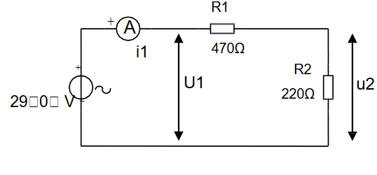
Name | Measurement | Calculation
I1 | 0.004 A
U2 | 9.35 V

Total impedance:
Z=R1​+R2​=470+220=690Ω
Current I:
I = V / Z=29∠0 /690 = 0.04203∠0∘ A
Rectangular form: 0.04203 +j0 A
B)
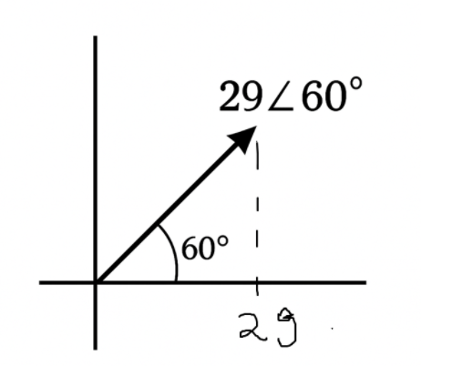
C)
i1​=0.04203(cos60∘+j sin60∘)
i1​=0.0210+j0.0364 A
Voltage across R2:
U2 = I1 * R2 = 0.04203⋅220=9.246
U2= 9.246∠60∘ V
U2​=9.246(cos60∘+jsin60∘)=4.623+j8.004 V
FINAL RESULTS:
For $29∠0^{∘}$V
i1​=0.0420+j0 A
u2​=9.246+j0 V
For $29∠{60}^{∘}$V
I1​=0.0210+j0.0364 A
U2​=4.623+j8.004 V

Circuit 2
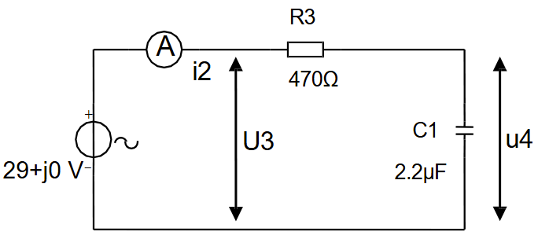
WE HAVE USED 50HZ FREQUENCY BECAUSE THERE ISNT ONE!
Capacitor impedance:
Zc1 = 1/j2 π FC = 1/ j2π⋅50⋅2.2×10^−6= −j1447Ω
Total impedance:
Z1 = R3+Zc1 = 470 −j1447Ω
Expected phasor diagram of $U_{3}$and $i_{2}$:
Circuit is RC series
Current $i_{2}$lags supply voltage
U3 across resistor is in-phase with current
U4 across capacitor is 90° lagging current
Calculate I2 and U4 (Cartesian):
∣Zt​∣=$√$(470^2+1447^2​)=1520
∣i2​∣=29/1520​=0.01908 A
Tan^−1(1447/470)=−72.2∘
i2​=0.01908∠72.2∘ A
Rectangular form:
i2​=0.01908(cos72.2∘+jsin72.2∘) = 0.00584 + j0.0182A
Voltage across capacitor:
U4​=i2​ZC1​=(0.00584+j0.0182)(−j1447)
U4=26.33 – j8.45 V
KVL:
U3​=i2​R3​=(0.00584+j0.0182)⋅470=2.74+j8.55 V
u3​+u4​=(2.74+26.33)+j(8.55−8.45)=29.07+j0.10
Within margin
Phasor difference:
Phase(U3)-Phase(I2) = 0∘

